Experiment Number : 01 Date:

Installation of Java and Simple Java Programs
Aim:
To install Java Development Kit (JDK), configure the environment, and write simple Java programs including Hello World.
PRE LAB EXERCISE
QUESTIONS
- What is JDK and why is it required?

JDK is a software kit used to develop Java programs and it includes compiler and tools. It is required to write, compile, and run Java applications.
- Difference between JDK, JRE, and JVM.

JDK is for development, JRE is for running Java programs, and JVM executes the bytecode. JDK contains JRE, and JRE contains JVM.
- What is the purpose of the main() method in Java?
The main() method is the entry point of a Java program. Program execution starts from this method.

IN LAB EXERCISE
Objective:
To verify Java installation and execute a basic Java program.
INSTALLATION STEPS:
STEP 1: Open Browser
- Open your browser and go to the official URL Eclipse Downloads page.

STEP 2: Download Eclipse Installer
- Then, click on the "Download" button to download Eclipse IDE.

STEP 3: Download EXE
- Now, click on the "Download x86_64" button.
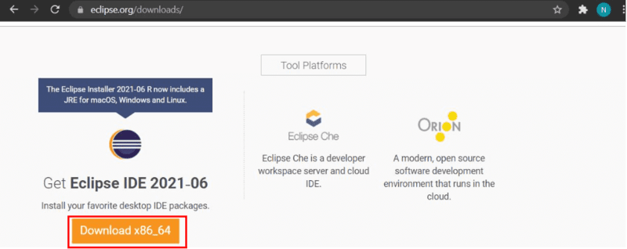

STEP 4: Then click on the "Download" button. After clicking on the download button the .exe file for the eclipse will be downloaded.

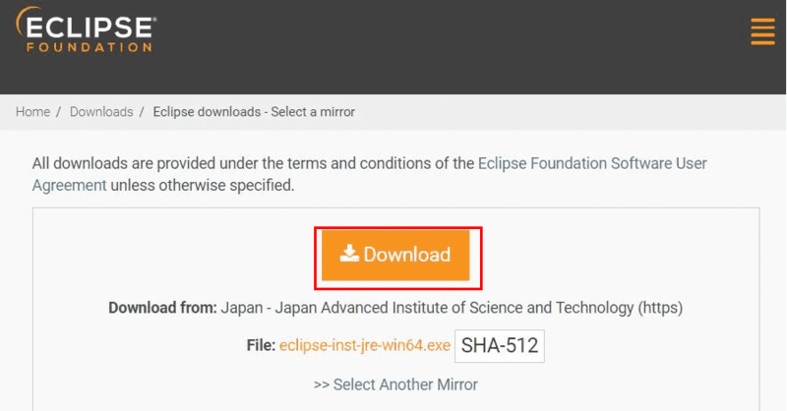

STEP 5: Open Download EXE
- Now go to File Explorer and click on "Downloads" after that click on the "eclipse-inst-jre-win64.exe" file for installing Eclipse IDE.

STEP 6: Install Eclipse
- Then, click on "Eclipse IDE for Java Developers".
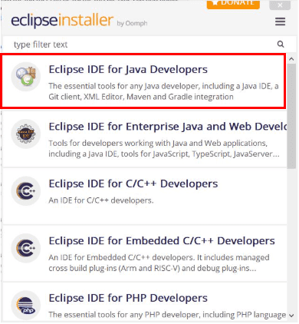

STEP 7: Then, click on the "Install" button.

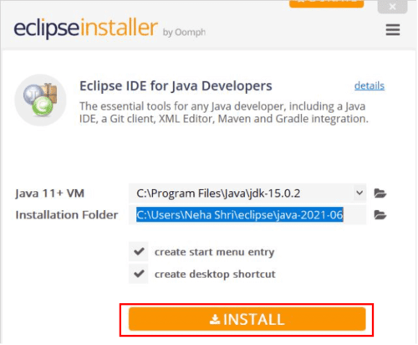
Step 8: Create New Project
Now click on "Create a new Java project".
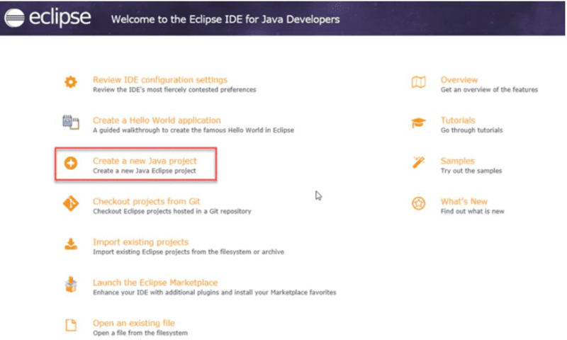
STEP 9:Create a new java project
- By clicking on the File menu and choosing New → Java Project.
- By right clicking anywhere in the Project Explorer and selecting New → Java Project.
- By clicking on the New button ( ) in the Tool bar and selecting Java Project.
STEP 10: Enter the Project Name
- Select the Java Runtime Environment (JRE) or leave it at the default
- Select the Project Layout which determines whether there would be a separate folder for the source codes and class files. The recommended option is to create separate folders for sources and class files.
- 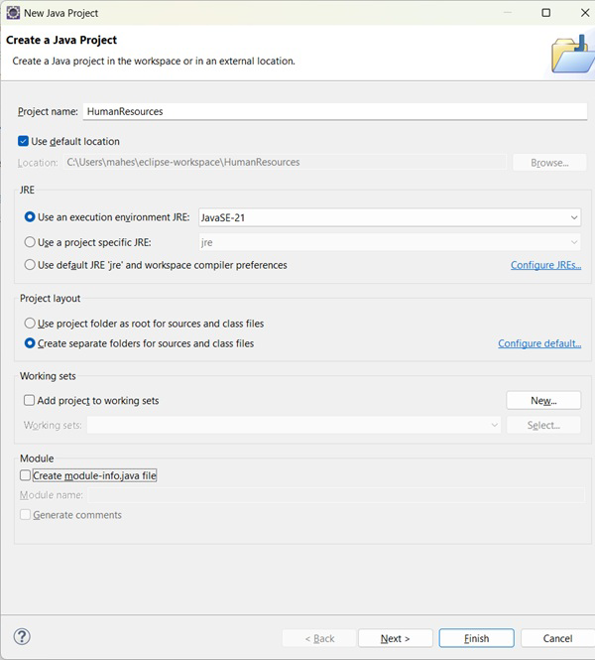
STEP 11: Create a new java package
- By clicking on the File menu and selecting New → Package.
- By right click in the package explorer and selecting New → Package.
- By clicking on the package icon which is in the tool bar( ).
STEP 11:
- Enter/confirm the source folder name.
- Enter the package name.
- Click on the Finish button.
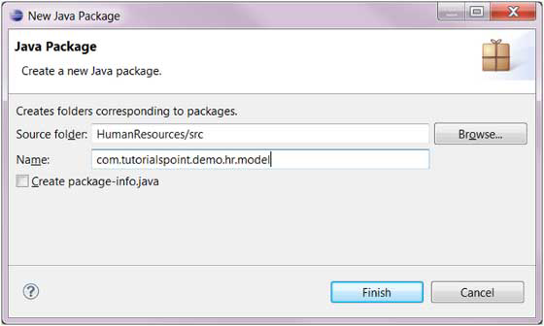

STEP 12:Create a New Java class.
- By clicking on the File menu and selecting New → Class.
- By right clicking in the package explorer and selecting New → Class.
- By clicking on the class drop down button ( ) and selecting class ( ).
STEP 13:
- Ensure the source folder and package are correct.
- Enter the class name.
- Select the appropriate class modifier.
- Enter the super class name or click on the Browse button to search for an existing class.
- Click on the Add button to select the interfaces implemented by this class.
- Examine and modify the check boxes related to method stubs and comments.
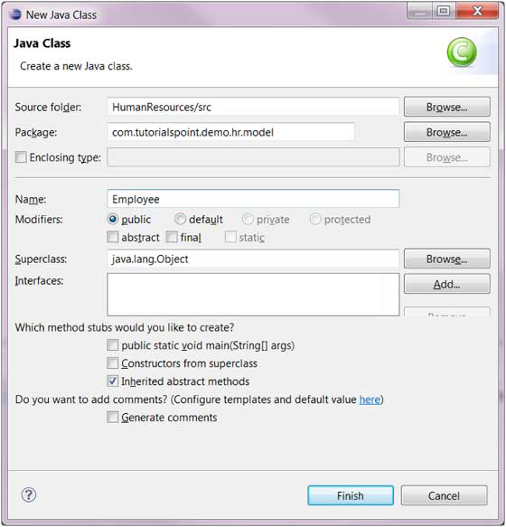

STEP 14: Class created successfully.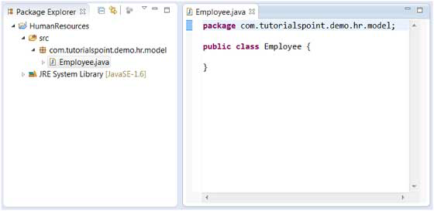

BASIC PROGRAMS:
Program 1: Hello World Program
Source Code:
class HelloWorld {
public static void main(String[] args) {
System.out.println("Hello World");
}
}
Output:
Hello World
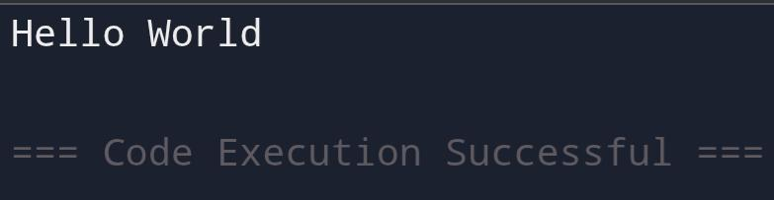

Program 2: Display Personal Details
Source Code:
class DisplayInfo {
public static void main(String[] args) {
System.out.println("Name: Anitha");
System.out.println("Age: 20");
}
}
Output:
Name: Anitha
Age: 20
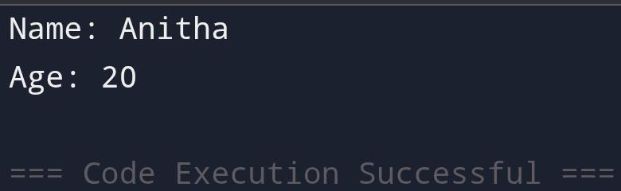
Program 3: Addition of Two Numbers
Source Code:
class AddTwoNumbers {
public static void main(String[] args) {
int a = 10, b = 20;
System.out.println("Sum = " + (a + b));
}
}
Output:
Sum = 30
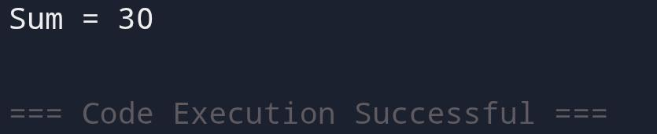
Program 4: Area of a Rectangle
Source Code:
class AreaRectangle {
public static void main(String[] args) {
int length = 10, breadth = 5;
System.out.println("Area = " + (length * breadth));
}
}
Output:
Area = 50
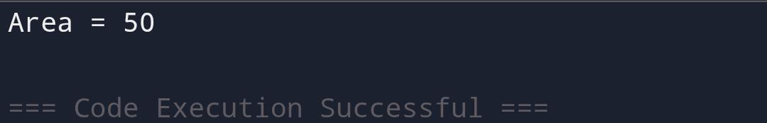
Program 5: Simple Interest Calculation
Source Code:
class SimpleInterest {
public static void main(String[] args) {
int p = 1000;
int r = 5;
int t = 2;
int si = (p * r * t) / 100;
System.out.println("Simple Interest = " + si);
}
}
Output:
Simple Interest = 100
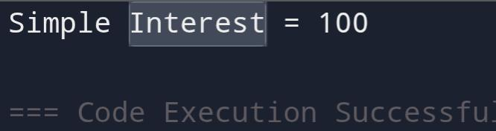

POST LAB EXERCISE
- Write a Java program to display your name and department.
Class Display {
Public static void main(String[] args) {
System.out.println(“Name: Gamer Ryder”);
System.out.println(“Department: Computer Science”);
}
}

- Modify the program to print the output in same line.

Class Display {
Public static void main(String[] args) {
System.out.print(“Name: Gamer Ryder “);
System.out.print(“Department: Computer Science”);
}
}

- What happens if main() is written without static?

The program will not run.
JVM cannot call main() without static because no object is created.

- Why is Java called platform independent?

Java programs are compiled into bytecode, which runs on any system with a JVM, regardless of the operating system.

- Write a program to find the cube of a number.
Class Cube {
Public static void main(String[] args) {
Int num = 3;
Int cube = num * num * num;
System.out.println(“Cube: “ + cube);
}
}

Result:

Thus the Java IDE was successfully installed and a simple Java program was executed.

ASSESSMENT

Description | Max Marks | Marks Awarded
Pre Lab Exercise | 5
In Lab Exercise | 10
Post Lab Exercise | 5
Viva | 10
Total | 30
Faculty Signature

